The Natural, Agricultural and Structured Environments of the Lower Rio Grande Valley:

A Sustainability Network for Alignment of Thought and Action on Issues

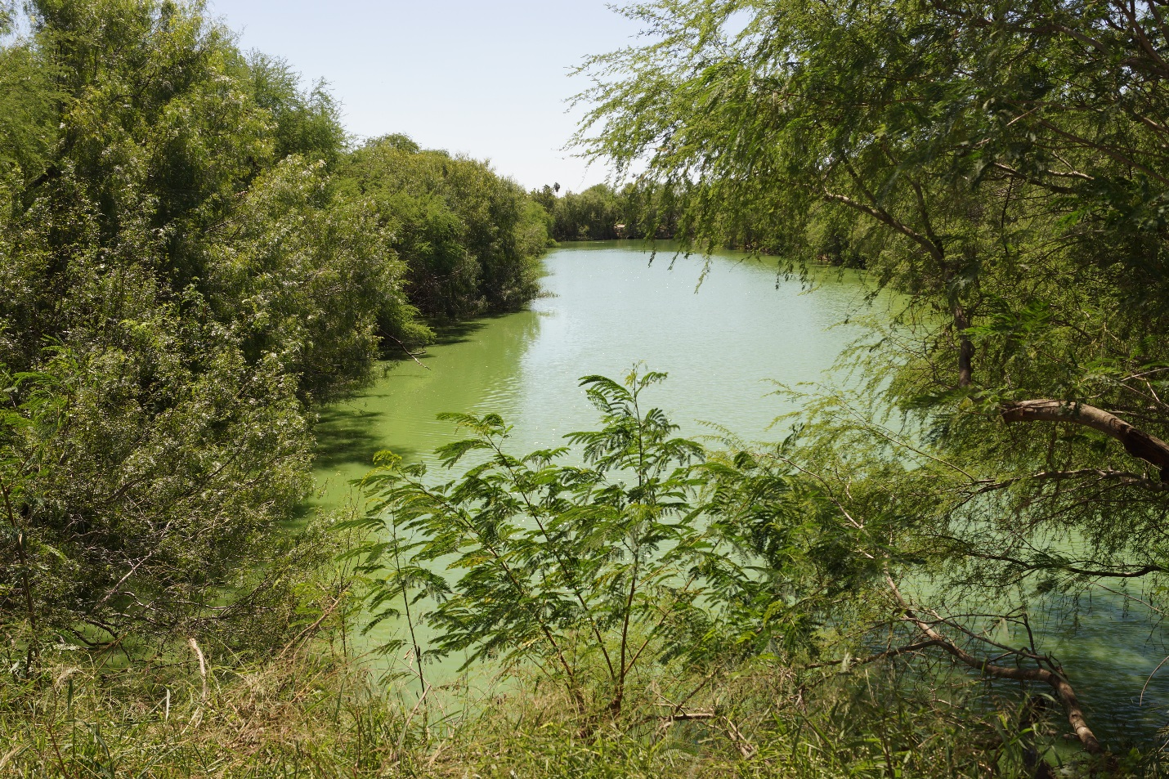

Workshop Summary
30 October 2105

- Background
  - LRGV sustainability issues

The Lower Rio Grande Valley (LRGV) is a patchwork of agricultural, structured and natural environments. The proportion of these environments has changed tremendously over the past 50 years and will likely continue to do so because of population growth. Population growth will stress all three environments but in different ways. As a result, there is a need for a comprehensive approach to deal with this changing landscape and maintaining its sustainability. To ignore this need will impact the quality of life in the LRGV. A step in the development of a comprehensive approach is to organize a Sustainability Network of entities interested in the future of the LRGV.

  - An approach to dealing with LRGV sustainability issues

There are entities in the LRGV that are addressing some sustainability issues. In some cases, multiple groups are working on the same issue but without knowledge of each other’s efforts. Some groups are underfunded in their efforts to deal with an issue. Some issues are complex and are not being addressed. Groups that want to address a complex issue may need expertise that could be provided by academics and consultants. The LRGV Sustainability Network (Network) is intended to be a hub of information about current issues, existing sustainability efforts, and groups seeking partners to work on issues all to enhance existing efforts and nurture new approaches.

- Workshop
  - Purpose and Approach

A major goal of the workshop was to get participants to exchange perspectives on LRGV sustainability issues, building on what was accomplished in the May workshop. Another goal was to discuss methods of prioritization of issues. In the afternoon, the structure of the Network, problem-solving and information sharing were covered.

  - Participants

A variety of entities were invited to the workshop and included government agencies (state and federal), non-governmental organizations, agriculture, academics and local governments. The purpose of this variety was to gain a sweep of perspectives on LRGV sustainability issues. Unfortunately, due to inclement weather that day, some of the confirmed participants could not attend. Below is the list of participants:

Jim Chapman Frontera Audubon
Tony Reisinger Texas Sea Grant
Chris Hathcock U.S. Fish & Wildlife Service
Willy Cupit Texas Parks & Wildlife Department
Kim Jones TAMU Kingsville
David Hicks UTRGV
Robert Edwards UTRGV
Jude Benavides UTRGV
Marianella Franklin UTRGV
Frank Dirrigl UTRGV
Hudson DeYoe UTRGV

  - Funding source
Funding for the workshop was provided by the RCN-SEES: Climate, Energy, Environment, and Engagement in Semi-Arid Regions (CE³SAR). CE³SAR is funded by a National Science Foundation grant to Texas A&M University - Corpus Christi.

- Workshop products

  - LRGV Sustainability Issues
Through breakout sessions, the participants were asked to amend the LRGV sustainability issues list initiated in the May workshop. Below is a distillation of the suggestions made by the workshop participants. The unedited list is in Appendix A.

Breakout Group 1
- Water
  - High nutrient levels in the Rio Grande
  - Valley residence losing confidence in tap water
  - Flood control and stormwater management
  - Water quality issues in the Arroyo Colorado
  - Water quality and habitat issues in Cameron County resacas
  - Brackish vs. ocean desalination
  - Water reuse limitations and benefits
  - Expand the water list of concerns to include Quality vs. Quantity discussions for all types of water
- Habitat
  - Restoring native plant communities
  - Habitat loss and impact on native species
- Competing Use and Development Impacts
  - Invasive species
  - Dichotomy in coastal land development – tourism or industry?
- Climate Change as a broad topic that affects all of the these major topics and sub-topics
  - Focus more on impacts of global climate change on the LRGV- its remaining habitat, infrastructure, and humans
- Natural Disasters
  - Flooding
  - Drought and long-term sustainability of irrigated agriculture
  - Harmful algal blooms– red tide economic impact on ecotourism
  - How Space X and LNG might cope with all of the above….
- Use of Ecosystem by humans --- Major concerns with ACCESS to remaining and / or restored areas
  - Buzz phrase: “Many natural systems are right next door but seem miles away in the LRGV”
- Border area – Security, Access, and Habitat
  - Lots of discussion here on impacts of SOP’s for Border Patrol, border fence, etc.
Breakout Group 2
- Baseline contamination
- Ecological characterization of habitat
- Need for GIS database
- Need for assessment- inventory
  - List of areas that need restoration
- LNG development (prioritization in mitigation)
- Mechanism for identifying threats
- Residency disaster preparedness/ recovery
- Erosion problems
There was a discussion of the meaning of sustainability and how the Network could address the advancement of sustainability in the LRGV.

  - Prioritization
The intent of this session was to determine if there is a need to prioritize the LRGV issues (above) and if so, how to do it. Dr. Dirrigl presented a methodology then the group discussed.

Breakout Group 1
- Instead of coming up with a priority ranking, just name 5 issues that we have identified and then create committees/project groups within the Network.
- We can prioritize for internal Network purposes
- A list that represents the current status of the Valley/ Lower Rio Grande Valley/ ecological areas/ geopolitical/ etc. How would we split it up?
- Have “N/A” in the grading scheme for a criterion

Breakout Group 2
- Instead of assigning an issue a number 5 for most important, since every issue is important use the term “medium”.
- Assign the numbers but assign them to the broad topic (like water), then break it down to its sub-categories and then rank those.
- Need to first define the topic we are talking about and the current status of that topic. What are the threats? What can we do? What is our ultimate goal for that topic?
Where does our expertise lie? Should we focus on the issues that affect our expertise? Utilizing our strengths?

  - Assessment of the Workshop and Next Meeting

- How would you rate this workshop?
10 being the best and 1 being the worst. AVERAGE SCORE: 7.6
- What was your favorite aspect of this workshop?
  - Talking/discussion with workshop participants
  - Open exchange of ideas
  - ID of priorities discussion
  - Coming together to network with like-minded people. The openness of discussion and the opportunity to explain or define sustainability.
  - Building personal and professional relationships in LRGV
  - It addresses sustainability in the Valley
- What did you not like about this workshop? And how can we fix it?
  - Focus often wasn’t clear; sometimes we seemed to be floundering
  - Attendance- need to increase # participants
  - Participants should stay for the entire meeting
  - Still lack of clarity; Should be addressed by future meeting
  - Need greater number/scope of participants
  - Length of time- not sure how to fix it because we need the time
- Was the workshop how you imagined it? If not what did you expect the see?
  - Are we to be a resource for the community or are we to lead the community towards agreed upon goals such as an estuary program?
  - Better than expected
  - Yes
  - I honestly did not know what to expect since I missed the first meeting
  - Needs more participation/ members
    - Bad weather impacted meeting
- What would you like to see in the next workshop?
  - Refine our purpose and direction
  - Keep moving forward
  - Greater refinement of goals
  - More participation from Economic and Social
  - Examples of effective partnerships and outcomes. CBBEP??
  - More attendees
- What date would be a good time to have another meeting?
  - 2 or 3 months
  - Open
  - Any
  - August
  - Open
  - Jan 2016

- Network Structure and Function

Dr DeYoe proposed a Network structure that included characterization of the Network membership, selection of members and a Board of Directors. A constitution for the Network is being developed by Dr DeYoe for the next meeting.

Dr DeYoe presented a strategy for information-sharing and creating partnerships within the Network using internet tools:
- CSS website (http://faculty.utpa.edu/orgs/css/)
  - Calendar & Events
  - White papers and publications
  - Topic expert list
- Blog(s)- online conversations (http://subtropicalstudies.blogspot.com/)
- Facebook (https://www.facebook.com/)
  - Multimedia sharing
  - Engagement – The number of likes, comments, and shares you receive
  - Group creation for specific topic
  - Analytics available
- Wikispace http://riograndevalleyenvironmentalissues.wikispaces.com/home
- Pinterest- image sharing
  - Allows grouping of images
  - Collaborative function
- Google+
  - Group (Communities) created for specific topics
  - Video chatting (up to 10 people)
- DropBox and Google docs- sharing documents for input
- Twitter- content to be shared with followers
- WebEx or Skype- on-line meetings

- Future of the Network

Where we are:
-Two workshops held (May, Oct) with modest attendance and diversity of participants
-Developed a preliminary list of LRGV issues related to sustainability
-Discussed prioritization of issues
-Discussed potential roles of Network
-Workshop participants interested in seeing Network developed
-Questions about the next step and speed of development

What is missing?
-Formal organization of the Network
-How Network will function
-Diversity of participants needs to increase
-Selection of issue(s) to address
-Experts list is needed
-Find funding sources and prepare proposals
-Support letters needed
-Date and agenda for next meeting

Ideas for future meetings

Potential speakers

-Ray Allen, Corpus Christi Bays & Estuaries Program, comprehensive conservation management planning
-John Jacobs,Texas Sea Grant, coastal smart growth
-John Herron, Nature Conservancy (Texas Chapter), coastal management
-Alex Racelis, UTRGV, sustainable agriculture network

Public forums
-Sustainability in the LRGV
-Climate change
-Habitat loss
-Drainage and flood control
-Smart growth

Symposia
-Habitat management
-Invasive species/endangered species
-Restoration science
-Water quality and quantity management

LRGV Sustainability Network
Concept
Introduction
The LRGV Sustainability Network (the Network) is intended to enhance, facilitate and expand all that is being done to address sustainability of the Lower Rio Grande Valley (LRGV). It is important to know that sustainability is where:
- Natural resources are used responsibly so that they can be renewed naturally;
- The structured environment contributes to a sense of revival and rejuvenation;
- There is zero waste – waste is reduced, reused, recycled, repurposed, retrofitted, or composted;
- Sustainability principles are embedded in decision-making, planning and actions of individuals; and
- All members of the community are enriched by the experience of working within its boundaries.
Sustainability approach has three main components- economic, social and environmental. In a sustainable approach, all three components are equally addressed. To be meaningful, successful sustainable approaches must developed by a diverse array of entities that together have the knowledge and skills to effectively address an issue. A democratic process of decision-making in the Network is essential to assure that all points of view are represented.

Network Structure
The Network will consist of members from business, agriculture, local government, state and federal agencies, academics and non-governmental organizations. The Network is intended to be a democratic organization so all groups will have an equal say in what the Network does. Charter members are those that have participated in the development of the Network. New members will be nominated by existing members. From the membership, a Board of Directors will be formed with one member of each interest group being elected to a Board of six members. The Board will select a Chair, Secretary and Treasurer and will meet quarterly. The Board will select a Network Manager to deal with the daily activities of the Network and be a link between the Board and the members. The Network Constitution will contain the details of Network structure. The Network as a whole will have an annual meeting. At this meeting, focus groups (see below) will provide updates on their efforts, speakers on select topics will be invited, and a public forum on a current issue will be organized.

Activities of the Network

Education
Education is an essential part of the Network. Valley residents and especially decision-makers need to have an understanding of the sustainability approach and local issues. Children and young adults need to be educated on the difference between sustainable and non-sustainable actions. Education can be achieved through a variety of ways including: public forums, invited speakers, science conferences, and school/university curricula. It is important to have a reliable source of information about local issues so the Network will use a range of internet tools to disseminate factual information. Social media tools will be used to have productive discussions of issues by a wide range of interest groups.

Creating partnerships
There are entities in the LRGV that are addressing some local sustainability issues. In some cases, multiple groups are working on the same issue but without knowledge of each other’s efforts. Some issues are complex and are not being adequately addressed. Some groups are underfunded in their efforts to deal with an issue. The Network is intended to be a hub of information about existing efforts and groups seeking partners to work on issues. Groups that want to address a complex issue may need expertise that could be provided by academics and consultants. The Network will create a searchable list of experts.

Addressing issues
Issues that are not being addressed or not being effectively addressed warrant the formation of focus groups who can develop comprehensive sustainable strategies. Focus groups will likely need resources such as staff support, meeting venues and information. The Network is intended to provide support to focus groups until the group has completed their goal(s). Newly formed focus groups can submit a proposal to the Network detailing their effort and resource needs. The Network membership will vote on support requests.

Finances
Funds for the Network to perform its functions will be provided by external grants and donors.

